**1、The points of key**

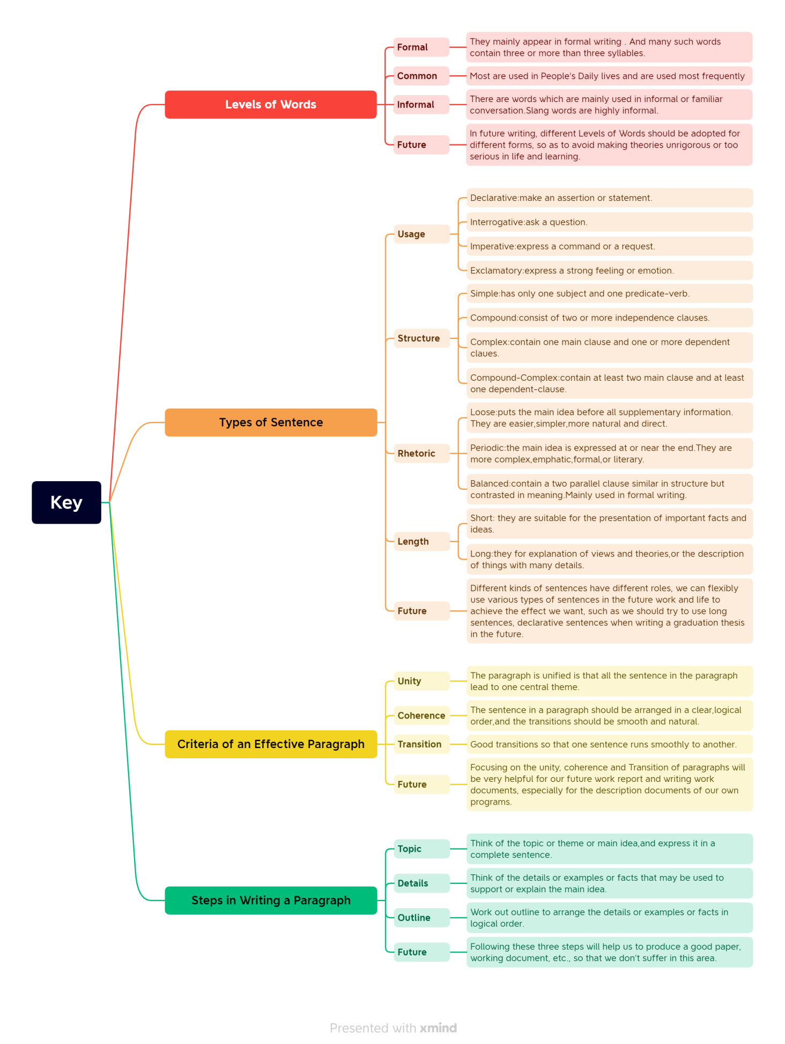

**2、**

1. **My Learning**

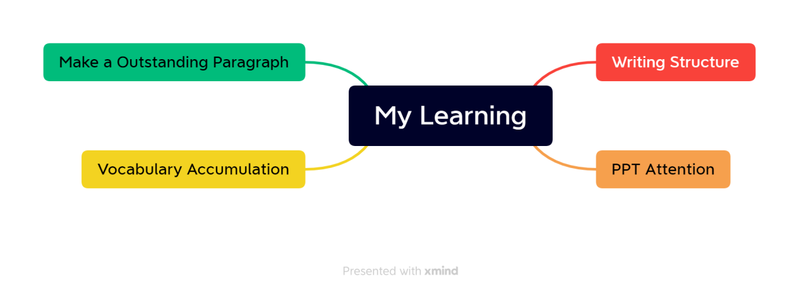

1. **Learning outcomes**

In this week's class, I learned some basic knowledge about writing and making ppt, such as the basic framework of the paper, the main framework of the essay, the focus of writing, and the main color of ppt making should be sunny and cheerful, so as not to leave a negative first impression on people.

Besides, I also learned a lot outside class, such as the specific classification of a sentence and its related functions, the standards that an excellent paragraph should have and how to write an excellent paragraph. In addition, I also completed vocabulary accumulation on time and reviewed the old and learned new things.

In the future when making ppt, I will pay special attention to the overall tone; In the future writing work documents will have a focus to write; When sending invitations or other important letters, pay special attention to unity, coherence and Transition.